146

3.6 STATE POLICY ON CLUSTER DEVELOPMENT IN THE REPUBLIC OF MOLDOVA: OPPORTUNITIES AND OBSTACLES

Dr. Alexandra Novac

Scientific Research Coordinator,

National Institute for Economic Research,

Chişinău, Moldova

Dr. hab. Elena Aculai

Leading Researcher,

National Institute for Economic Research,

Chişinău, Moldova

ABSTRACT

Entrepreneurs, researchers, and the government of Moldova have only re-cently turned their attention to the problems of creating clusters. Clusters are a relatively new phenomenon in the Moldovan economy. By cooper-ating, sharing existing resources and conducting joint activities, clusters have contributed a great deal to enterprise development in the country. The cumulative positive effects of clusters enable small and medium en-terprises (SMEs) to overcome some of their problems as well as increase their innovative activity and competitiveness.

This paper analyzes the development of the SME sector in the Republic of Moldova, and provides a quantitative assessment of SMEs’ contribu-tion and potential. State policy on cluster development in Moldova will be explored, and the factors contributing to the risks and barriers of cluster creation in Moldovan cluster development policy will also be examined. This study compiles analyses of statistical data and international rankings, and the authors’ previous survey results with entrepreneurs.

Keywords: cluster, enterprise, small and medium enterprises, associa-tion, Republic of Moldova

JEL Classification: O25, O38, L50

147

3.6.1 SMES’ POTENTIAL AND THEIR CONTRIBUTION TO THE COUNTRY’S DEVELOPMENT

3.6.1.1 Main indicators of the SME sector in 2014

The role of small and medium enterprises (SMEs) in resolving the socio-economic problems of many countries throughout the world has visibly grown in recent years. This is true, regardless as to the different countries’ level of economic development. It is now established that SMEs enhance employment of the labour force, contribute to jobs creation, saturation of the consumption market, middle-class formation, as well as the creation and implementation of innovation.

According to the National Bureau of Statistics of Moldova (NBS), there were 53.7 thousand economic agents in the country in 2014; of which 97.4% were SMEs. This represents approximately 31.7% of all enterprises registered within the State Registration Chamber (SRC).

Moldovan SMEs have contributed significantly to jobs creation. In 2014, 56.2% of all employees of the national economy worked for SMEs. SMEs made up 31.8% of all sales revenue and created 82.3% of total profits before taxation. SMEs’ share in GDP (market prices) was 32.2% in 2013. However, SMEs’ share in export is still very low at 13% in 2009 (see Figure 1).

Figure 1: SMEs’ Share in the National Economy of the Republic of Moldova in 2014
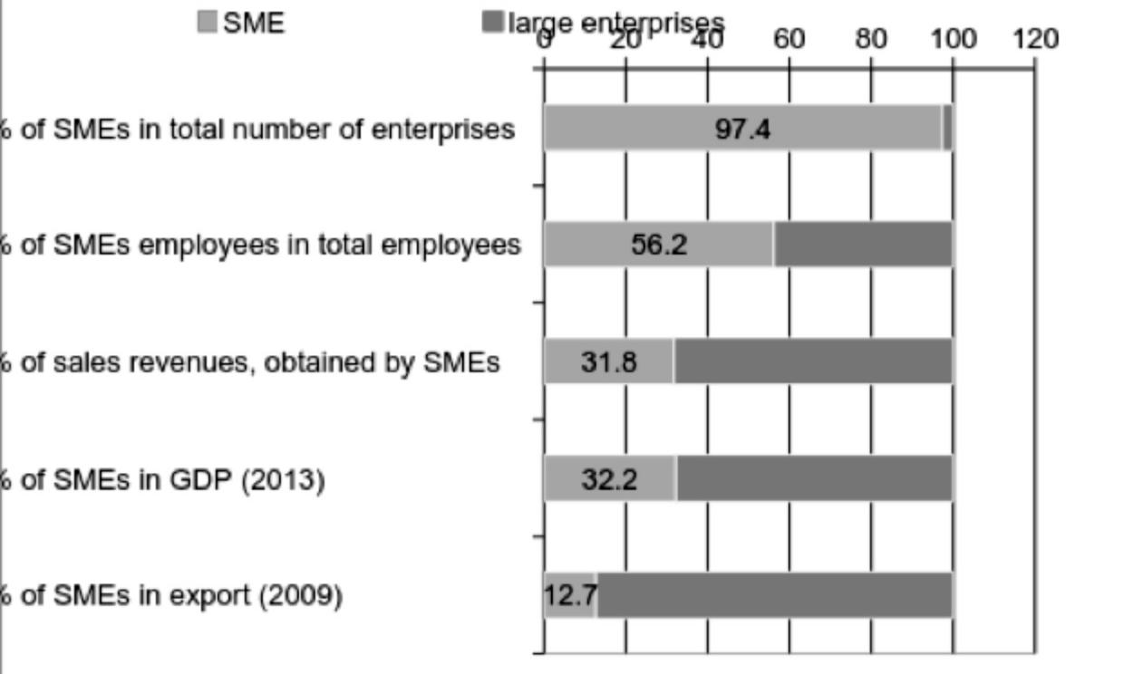

Source: Authors’ calculation, based on statistical data

148

Of the total number of SMEs in the country, 77.6% are microenterprises, 19.3% are small enterprises and 3.1% are medium enterprises. The main indicators of the Moldovan SME sector are presented in Table 1.

Table 1: Main indicators of the Moldovan SME sector in 2014
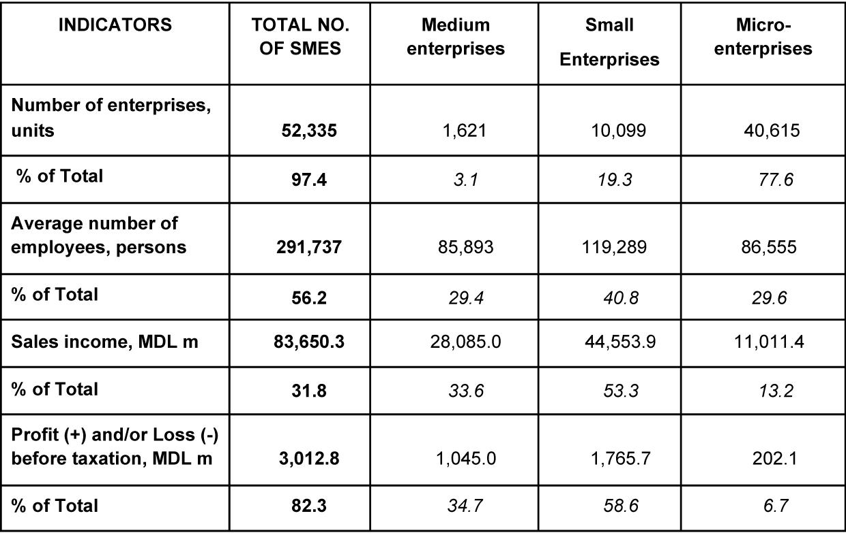

Source: Authors’ calculation based on statistical data

3.6.1.2 DATA ON THE NUMBER OF REGISTERED AND LIQUIDATED ENTERPRISES

The State Registration Chamber (SRC) of the Moldovan Ministry of Justice provides data on the number of registered and liquidated enterprises in the country. This data could be used to monitor trends in entrepreneur-ship development in Moldova. This information is accumulated in the State Registration Chamber’s database, where all the registered and officially liquidated enterprises are recorded. According to SRC data, there were 168,273 legal business entities and individual entrepreneurs in Moldova as of 1 February 2015.

The number of registered and deregistered enterprises in the SRC in 2013-2014 is indicative of the poor performance of the business entities in the country. In 2014, there were two times as many registered enterprises as liquidated/deregistered ones that were officially excluded from the SRC,

149

and there was a net increase of 3,493 enterprises. However, as seen in Table 2, the number of enterprises in Moldova in 2014 was only 102% the number of existing enterprises in 2013. During that same period, the average number of registered enterprises increased by 521.9 per month and the number of deregistered companies decreased from 234 in 2013 to 230.8 in 2014. These figures are significant when it is borne in mind that the enterprise registration procedure is relatively easy, while the proce-dure to officially close a business is extraordinary complex and drawn out. This could indicate that some entrepreneurs who have ceased activities and intend to close down the business have yet to successfully do so.

3.6.1.2 DATA ON THE NUMBER OF REGISTERED AND LIQUIDATED ENTERPRISES

The State Registration Chamber (SRC) of the Moldovan Ministry of Justice provides data on the number of registered and liquidated enterprises in the country. This data could be used to monitor trends in entrepreneur-ship development in Moldova. This information is accumulated in the State Registration Chamber’s database, where all the registered and officially liquidated enterprises are recorded. According to SRC data, there were 168,273 legal business entities and individual entrepreneurs in Moldova as of 1 February 2015.

The number of registered and deregistered enterprises in the SRC in 2013-2014 is indicative of the poor performance of the business entities in the country. In 2014, there were two times as many registered enterprises as liquidated/deregistered ones that were officially excluded from the SRC, and there was a net increase of 3,493 enterprises. However, as seen in Table 2, the number of enterprises in Moldova in 2014 was only 102% the number of existing enterprises in 2013. During that same period, the average number of registered enterprises increased by 521.9 per month and the number of deregistered companies decreased from 234 in 2013 to 230.8 in 2014. These figures are significant when it is borne in mind that the enterprise registration procedure is relatively easy, while the proce-dure to officially close a business is extraordinary complex and drawn out. This could indicate that some entrepreneurs who have ceased activities and intend to close down the business have yet to successfully do so.

150

Table 2: Number of enterprises registered and liquidated/deregis-tered in SRC in 2012-2014,
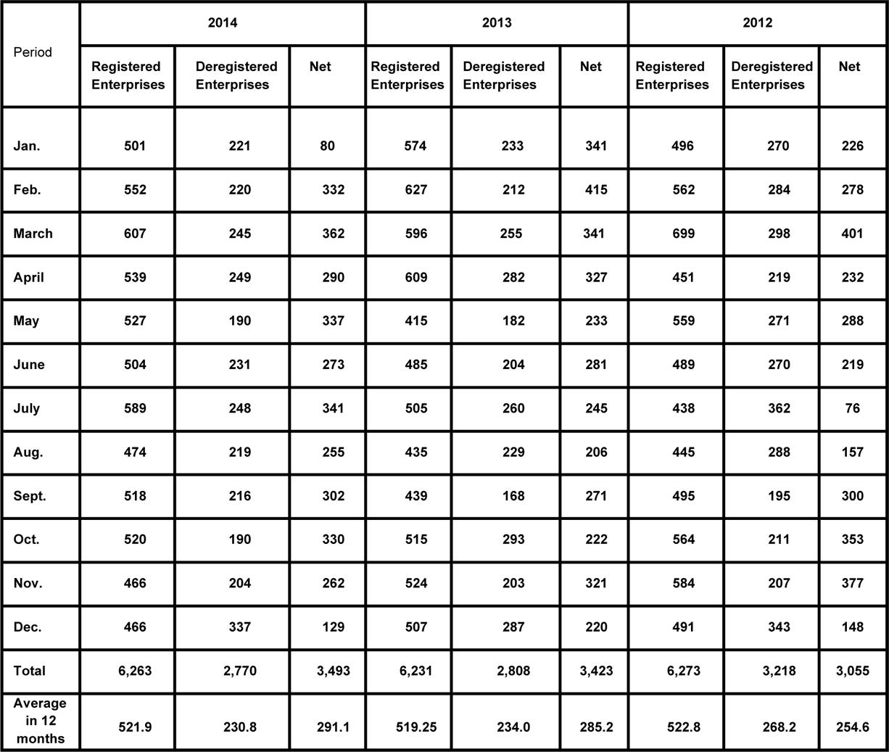

Source: Author’s calculations based on SRC data

There was a slight decrease in the number of registered enterprises in 2006-2014. In contrast to the 8,396 new enterprises registered in 2006, the number of registrations decreased by 25.4% to 6,263 in 2014. The overall number of enterprises registered in 2014 increased insignificantly by 0.5% compared to the previous year.

While 1,830 enterprises were deregistered in the SRC in 2006, the number of deregistrations in 2014 rose by 51.3% to 2,770. There was, however, a 1.4% decrease in the number of deregistered enterprises in 2014 when compared to 2013.

151

Figure 2: Registrations and Deregistrations in the State Register in 2006-2014, units
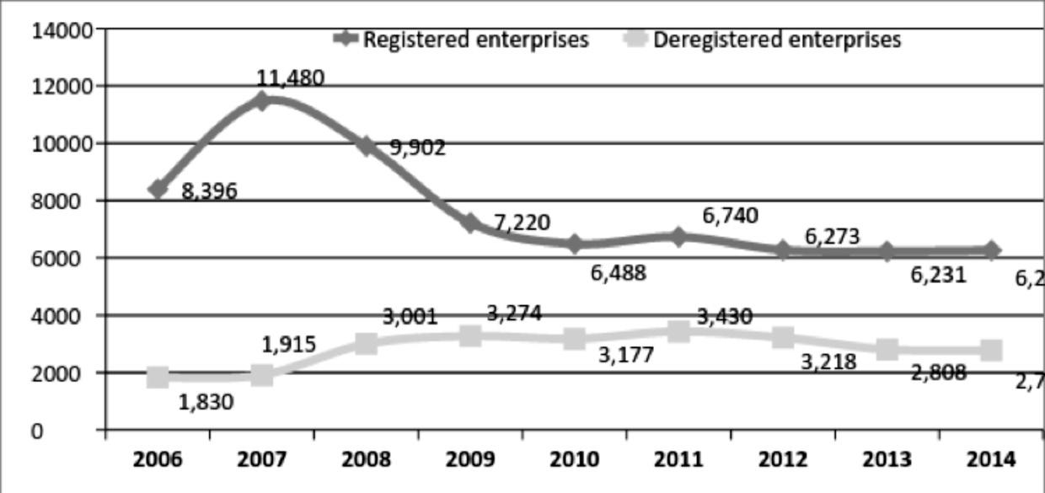

Source: SRC data

3.6.2 MOLDOVA’S INNOVATION SCOREBOARD

SMEs’ enhancement of their capacity to absorb and generate innovations is critical to their involvement in the national innovation system.

The government has empowered the Academy of Sciences of Moldova to develop, elaborate and promote innovation and technology transfer policy. The Agency for Innovation and Technology Transfer (AITT) is tasked with implementing state policy in innovation and technology transfer, and facili-tating the partnership between research organizations, higher education institutions and the business sector.

The state policy for innovation and technology transfer was adopted by the government of Moldova in 2013, and led to the creation of a legisla-tive framework on innovation and incubation. Some of the most important documents on innovation and technology transfer within this policy frame-work are: [4]

- The Code on Science and Innovation of the Republic of Moldova nr.259-XV of 5 July 2004;
- The Partnership Agreement between the government and the Acad-emy of Sciences of Moldova;
- The Law on Scientific-Technological Parks and Innovation Incubators nr.138-XVI of 21 June 2007;

152

- The innovation strategy of the Republic of Moldova “Innovations for

Competitiveness” 2013-2020.

However, state efforts remain ineffective, and they do not meet the expec-tations of entrepreneurs. Potential entrepreneurs still have minimal impact on the development of the SME sector, due to weak ties of cooperation between public authorities responsible for policy innovation, industry and academia as well as other factors. [4]

There are currently 8 innovation incubators in Moldova – one in the Sci-ence and Technology Park “Academica”, one in the Science and Technology Park “INAGRO”, and six in the universities. Five of them are in Chişinău, and two are in Balti and Comrat. All the innovation incubators in Moldova are non-profit, and the state is their main partner and sponsor.

These incubators were created under the Law on Scientific-Technological Parks and Innovation Incubators. The law outlines measures to support and encourage innovation and technology transfer activities of incubator residents. Although the law initially provided residents important tax and customs facilities, these were later cancelled in 2012. [4]

Moldova continues to face a number of intellectual property problems. Residents in the innovation incubators are anxious over the protection of their intellectual property, more so because intellectual property is not yet central to the economic, social and cultural development of the country. Furthermore, Moldova does not recognize the importance of the value of intangible goods (assets) such as intellectual property. For example, resi-dents who wish to obtain loans from commercial banks may leave some intellectual property rights as pledges, but they fail to obtain any funding because banks are reluctant to recognize these rights and assess their value. [6]

Figure 3 shows the share of patent applications filed by national applicants in 2006-2013. As can be seen in Figure 3, individuals filed 39% of patents, institutions of the Academy of Sciences filed 27.8% of patents, and com-panies filed only 3% of patents. The low share of SME patenting is due to two major reasons:

- Companies are unwilling to innovate.

- Companies believe that patenting procedures and maintenance are very costly.

153

Although SMEs are offered a number of discounts in intellectual property registration fees, they do not have sufficient financial resources. Moreover, a significant part of inventions owned by individuals are generated in aca-demia and industry. Given the fact that most inventions are perceived to have low applicability, academia and industry usually have no interest in them. Thus, they give up their patents to these inventions and individual inventors.
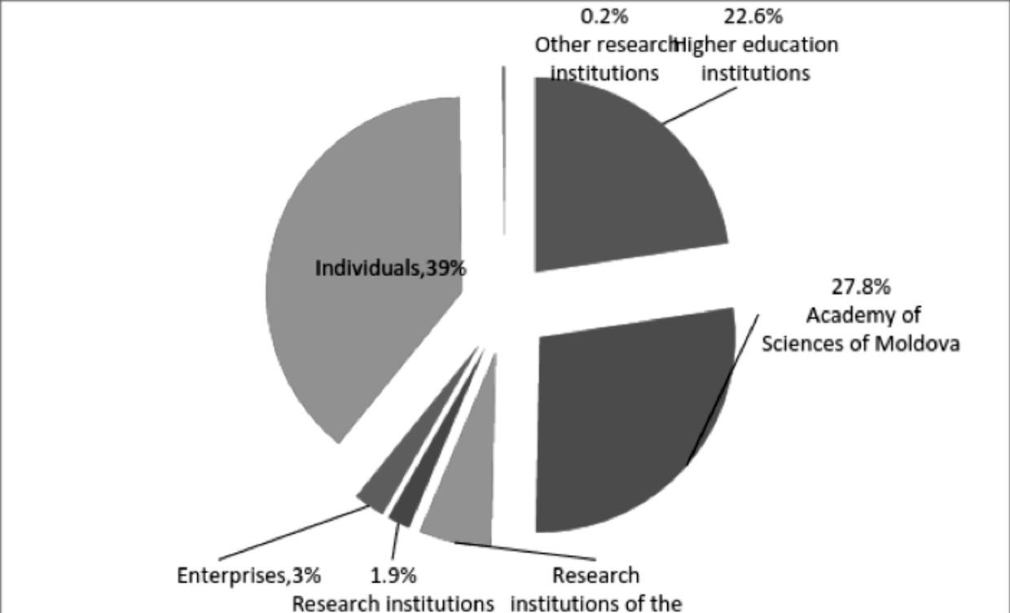

Figure 3: Share of patent applications filed by national applicants in 2006-2013

Source: Authors’ calculation based of the data from the State Agency on Intellectual Property

According to the study “Recommendations for strengthening the role of small and medium-sized innovation enterprises in countries of the Com-monwealth of Independent States” [11], there are no essential changes in the innovation development of SMEs in CIS. However, most countries, including Moldova, are taking steps to enhance innovation in economic development so as to support the SME sector.

The real action of the developed and adopted legislation in this area is greatly neutralized by the underdevelopment of market relations, the low level of maturity of the competitive environment, bureaucracy, limited fi-nancial resources necessary to create favourable conditions for innovative

154

SMEs, high risk, lack of proper infrastructure, low innovation culture, lack of information, the existence of more profitable fields for capital invest-ment, etc. [8]

The experiences of Western countries have shown that innovation devel-opment will enhance the competitiveness of the SME sector. However, the colossal reserves of the SME sector in Moldova remain insufficiently ex-ploited. There are many factors hindering the development of SMEs. To highlight the Moldovan SME sector’s problems in accessing innovations, the authors conducted interviews and surveys, and consulted various pub-lications and materials published in the last 3-4 years.

According to research gathered from the authors’ interviews and surveys

- [2] [4], entrepreneurs encounter several obstacles in developing their innovation projects. The main barriers limiting SMEs’ access of innovation are:
• High acquisition cost of technology or development of new products/ services. Respondents stated that, in their opinion, the cost of equip-ment is quite high, and its acquisition requires additional financial resources that they lack.

• Lack of qualified staff such as highly skilled engineers, technologists, programmers, etc. In order to be truly competitive, enterprises need different categories of personnel. Not only do the entrepreneurs dem-onstrate low innovative and research potential, their enterprises lack insufficiently skilled specialists in research and innovation activities.

There is also a dearth of skilled workers and specialists knowledge-able as to the workings of modern equipment, and new technolo-gies in production and management. The continued use of outdated equipment and technologies in many SMEs aggravate their lack of innovation.

• Lack of information on technologies and the market. Because the business sector and scientists lack the necessary information to search for partners, they do not know where to go for advice on cer-tain business needs or scientific achievements.

• Insufficient financial resources. The lack of financial resources is the biggest obstacle for SMEs wishing to innovate. SMEs’ insufficient fi-nancial resources are further exacerbated by the highly complicated process of borrowing financial resources. It is very difficult for SMEs to access grants for development of innovation, and bank loans are issued at very high interest rates.

155

- Poor or lack of collaboration between businesses and other institu-

tions stem from the following factors:

- A distrust of entrepreneurs regarding researchers. This increases en-trepreneurs’ reluctance to conduct dialogues with scientists and col-laborate with them.

- Entrepreneurs’ poor exposure to scientific language and results. The complex concepts, style and scientific language of researchers alien-ate entrepreneurs and place additional constraints on their coopera-tion with businesses.

It seems that the scientific community and universities are not ready to engage in entrepreneurial activities. Universities and research institutions appear more comfortable as “owners” of scientific research, because the researchers prefer to own the patents and use them to supplement their list of academic publications rather than to provide a right monopoly for commercial gains. [4]

3.6.3 THE POTENTIAL OF THE SME SECTOR

Employees and business assets are the main types of SME resources. One way of statistically determining human resources is the number of employ-ees in any one enterprise. In 2014, an SME employed an average of 5.6 persons; a medium-sized company had an average of 53 employees; a small business had an average of 11.8 employees; and a microenterprise employed an average of 2.1 persons. Throughout 2006-2014, the average number of employees fell from 9.4 persons to 5.6 persons.

Table 3: Number of employees in one company, 2006-2014
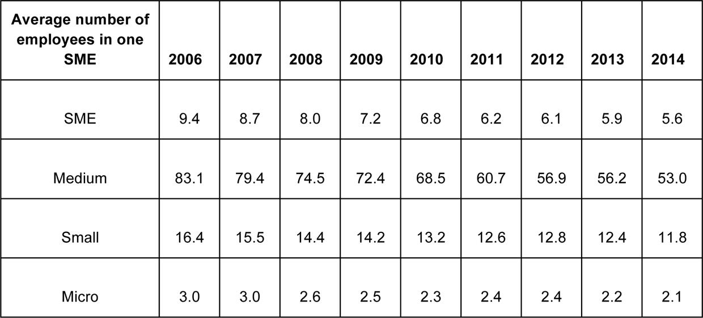

Source: Authors’ calculation based on NBS data

156

Moldovan enterprises have limited potential. As Figure 4 shows, an aver-age Moldovan SME has 5.6 employees, USD 93 thousand in financial as-sets, and sales revenues amounting to USD 79 thousand.
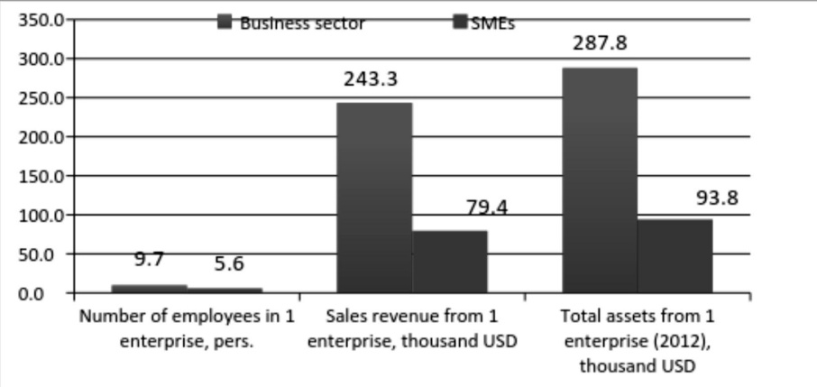

Figure 4: The potential of the SME sector in 2014 (On 30 Septem-ber 2015, 1 USD=20.14 MDL)
Source: Authors’ calculation based on NBS data

The state policy of SME development has to be improved in Moldova if the sector is to be more competitive, and increase its contribution to the country’s economic and social development.

Given Moldova’s budget deficit, the financial constraints of external donors and the ongoing model of SME management, public policy should not be exclusively focused on the methods of direct support. The provision of tax, credit, and other incentives requires significant financial expenditure from the state budget. To that end, the state should support SME development through institutional methods encompassing “soft” techniques such as: improving the dialogue between SMEs and public administration bodies, developing cooperation between enterprises, building confidence (trust) between businesses and the government, and so on.

The formation of clusters can help improve the socio-economic develop-ment of the SME sector. The participatory enterprises in a cluster can grow more competitive and innovative through joint activities such as the sharing of existing capacities, exchange of knowledge and transference of technology. [2]

157

3.6.4 MOLDOVAN STATE POLICY ON CLUSTER DEVELOPMENT

3.6.4.1 Prerequisites for creating clusters in Moldova

As in other CIS countries, clusters are a relatively new phenomenon in the Moldovan economy. Thus, issues related to the creation and problems of clusters have only recently attracted the attention of researchers. The obstacles and barriers to the development of enterprises in the clothing in-dustry cluster in Moldova were explored by researchers from the Academy of Economic Studies of Moldova. This research project, coordinated by Dr. C. Gutu, was titled “Elaboration of regional development models through cluster creation” and took place in 2009. Opportunities for cluster creation were also investigated in the research of Professor G. Belostecinic.

Dr. E. Aculai’s project on the “Identification of the main problems of SMEs in Moldova and elaboration of methodological materials for the creation and development of clusters” touched on issues germane to cluster cre-ation, and was conducted by researchers from the National Institute for Economic Research (NIER) in 2010. This project developed methodical materials supporting the creation and development of clusters, including the drawing up of a “cluster map”. These support measures were formu-lated as recommendations for the state policy on SME participation in the creation and development of clusters.

SMEs in Moldova need to improve their competitiveness, but their devel-opment is hindered by their limited capacities. As an upshot, they are un-able to innovate, develop export activities or protect the interests of small businesses vis-à-vis the authorities. Therefore, a policy spotlighting the

participation of SMEs in cluster creation is particularly relevant and meaningful.

The most important prerequisites for the development of clusters in Mol-dova are:

- SMEs’ limited access to all types of resources (financial, personnel, etc.). By cooperating, SMEs can pool their resources and increase their potential.

- High geographic concentration of SMEs, due to the small size of the country.

- Enterprises and SMEs already have some experience of cooperation through business associations.

158

- Public institutions (state agencies, research centres, etc.) have the ability and incentive to support the establishment and development of clusters.

- The practical experience of EU countries can be used to encourage

SMEs to participate in the creation and development of successful clusters.

Due to the small size of the country (stretching 350 km from north to south and 150 km from west to east), enterprises in Moldova are charac-terized by a relatively high degree of geographical concentration.

According to the National Bureau of Statistics of Moldova (NBS), there were 53.7 thousand enterprises in the country in 2014. This means there were 15.1 businesses for every 1,000 residents in Moldova in 2014 (see Table 4).

The high density of enterprises vis-à-vis the population necessitates an analysis of the size of the regional markets. In fact, there are major dispar-ities between the developing regions of Moldova and its capital, Chişinău. Enterprises in Chişinău have three times the number of employees than businesses in the developing regions.

Table 4: Share of enterprises by region, 2014
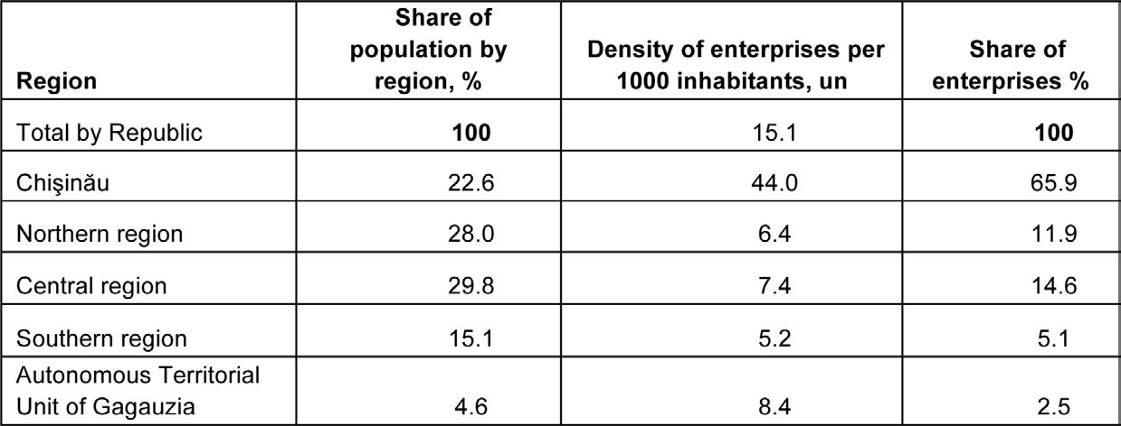

Source: Authors’ elaboration based on NBS data

Moldovan businesses have had some experience in cooperation. This fact was established in the 2011 research project “Analysis of existing forms of organizing the dialogue between SMEs and public administration bodies”. [3] Page 110 of this research project identifies the mechanisms that can

159

be used to strengthen SME and public administration dialogue at differ-ent levels of administration. This study showed that about 17.9% (of 107 respondents) of enterprises were members of business associations. Cer-tainly, compared to other countries with more advanced economies, this figure is modest. For example, 20-25% of SMEs in Southeast European (SEE) countries are members of business associations.

Research and educational institutions are able to offer innovation to clus-ters activities and the development of company staff. According to the National Bureau of Statistics in 2013, research and development activities was conducted in 64 units, including 40 institutes and research centres, 15 higher education institutions and 9 other units. Out of the total units with research and development activities, 53 units or 82.8% are owned by the state, including 20 institutional members of the Academy of Sciences, other research institutions and institutions of higher education. At the end of 2013, there were 4981 persons in the research and development sector. Of these, 35.9% were in the natural sciences, 13.8% in the technical sci-ences, 14.1% in the medical sciences, 12.3% in the agricultural sciences, and 12.6% in the social sciences. [9]

Moldova can also call on the vast practical experience of EU states in the initiation, creation and development of successful clusters. [9]

3.6.5 CLUSTER DEVELOPMENT IN MOLDOVA’S INDUSTRIAL SECTOR

The promotion of SME cooperation through clusters was encouraged in the state programme supporting the development of SMEs in 2009-2011.

The national strategy for industrial development also outlined the need for cluster policy. Currently, the government is implementing the Small and Medium Enterprise Sector Development Strategy for 2012-2020. One of the six priorities supporting SMEs in this Strategy is the development of business partnerships.

In August 2013, the government adopted the “Concept of Industrial Clus-ter Development of the Republic Of Moldova”. This concept was developed in accordance with the National Development Strategy “Moldova 2020” and the Industrial Development Strategy until 2015. The document ap-

160

proving the government’s adoption of the “Concept of Industrial Cluster Development” examined the premises for cluster development in the country’s industrial sector and concluded that the Moldovan economy had sufficient economic prerequisites for the creation and development of lo-cal and international clusters. Manufacturing industries in Moldova where clusters would most likely result in innovation and increased competitive-ness were the food and beverage industries; the manufacture of textiles, enterprises engaged in the dressing and dyeing of furs; the manufacturers of leather products such as footwear, etc.

The Concept of Industrial Cluster Development determines the purposes, objectives, general principles and steps through which state policy can support the development of clusters in industrial sector.

The Moldovan economy has many characteristics favourable to the stimu-lation of various forms of cooperation between enterprises such as the pre-dominance of SMEs in the country, the relatively high geographic concen-tration of businesses and the existence of business associations. Despite these favourable conditions for interfirm cooperation, the development of clusters has yet to take root in Moldova.

Clusters can be a promising form of association for enterprises in Moldova, as they have a positive impact on businesses within the clusters as well as on the country as a whole. The creation of clusters of Moldovan companies may confer the following benefits:

- Access to new markets

- Implementation of more innovations through the access to new tech-nologies

- Additional production capacity

- Reduction of costs and expenses due to their distribution among all members of the cluster

- Increased access to the labour force

- Opportunity to improve the image of the participants

- Positive trend of the results of the enterprise activity

- Improvement of the business climate in the region

Moldova may benefit from clusters in these ways:

- Successful clusters can provide an incentive for the development of existing enterprises and creation of new businesses

161

- Increasing the number of innovations

- Export growth

- Support for research and commercialization

- Increase budget revenues as a result of the increasing volume of col-lected taxes

- Increase the attractiveness of the country and its regions for invest-ment

- Increase the competitiveness of the country and its regions

In addition to securing the participation of SMEs and increasing their com-petitiveness, cluster formation policy has many other goals.

The goal is the development and implementation of a cluster policy that will encourage the effective and efficient cooperation of enterprises in any given industry so as to raise its competitiveness within the economy.

The main objective of the state policy supporting the development of clus-ters is to enhance the development of industrial sectors and increase their share in the national economy by strengthening the managerial and or-ganizational efforts, supporting the innovation process, and increasing the competitiveness of the large industrial enterprises and the SME sector

The specific objectives of the cluster policy are:

- Modernization of traditional branches of industry

- Create conditions for innovation activities, strengthening cooperation between enterprises and research institutions

- Increasing the efficient use of human, material and financial resourc-es through use of advanced technologies in the industrial production process

- Professional development of employees

- Support for regional economic development

- Growth of key financial and economic indicators of enterprises, and the subsequent increase of budget revenues

Clusters and the resultant intensive development of the industrial sectors are essential to the development of other sectors of the economy. This demonstrates that clusters can contribute to the promotion of domestic goods and trademarks to foreign markets and solve the country’s social problems at both micro and macro levels.

162

The cluster creation policy in Moldova is at its initial stage.

The government has outlined its support of cluster formation in industrial development in several strategic documents. These are:

- Programme of the Government of the Republic of Moldova “European

Integration: Freedom, Democracy, Welfare”

- Industry Development Strategy until 2015, approved by Government

Decision no.1149 on 5 October 2006 (p.6.2; Annex no.13 Action Plan, Chapters V, VI, VII)

- Small and Medium Enterprise Sector Development for 2012-2020

(Government Decision no.685, dated 13 September 2012)

- National Innovation Strategy of the Republic of Moldova “Innovation for Competitiveness” 2013-2020 (Government Decision no.952, dat-ed 27 November 2013)

- National Regional Development Strategy for 2013-2015 (Government

Decision no.685, dated 04 September 2013)

Before state policy supporting the development of clusters in the industrial sector can be realized, an effective mechanism providing multidimensional support of cluster formation and development should be conceptualized. Such a mechanism should be enshrined in the Strategy for the Develop-ment of Industrial Clusters.

The following elements should be included in this mechanism: [7]

- Legislative framework

- Scientific and methodological support for the preparation and realiza-tion of cluster policy

- Promoting the idea of clustering, and preparing the key persons in-volved in the creation and development of clusters

- Financing the cluster policy

- Identification of key organizations involved in the cluster formation policy

3.6.6 THE INITIATION OF CLUSTERS IN MOLDOVA

The presence of business associations in Moldova bodes well for the forma-tion of clusters, and analysts are able to make some preliminary prognos-tications on clusters in the country.

At the moment, there are two Moldovan cluster initiatives operating on a bottom-up approach: the Elchim-Moldova cluster and the innovative-educational InnoCluster.

163

There are 10 members in Elchim-Moldova, of which 2 are companies. Fig-ure 5 shows all ten participatory bodies in the Elchim-Moldova cluster. The main activities of the Elchim-Moldova cluster are:

- Technology transfer, the development and implementation of its own innovations, including advanced technology and equipment
- Development and coordination of training programmes for the devel-opment and promotion of innovations
- Further training of human resources and education

- Development of the innovative small and medium-sized enterprises within the cluster
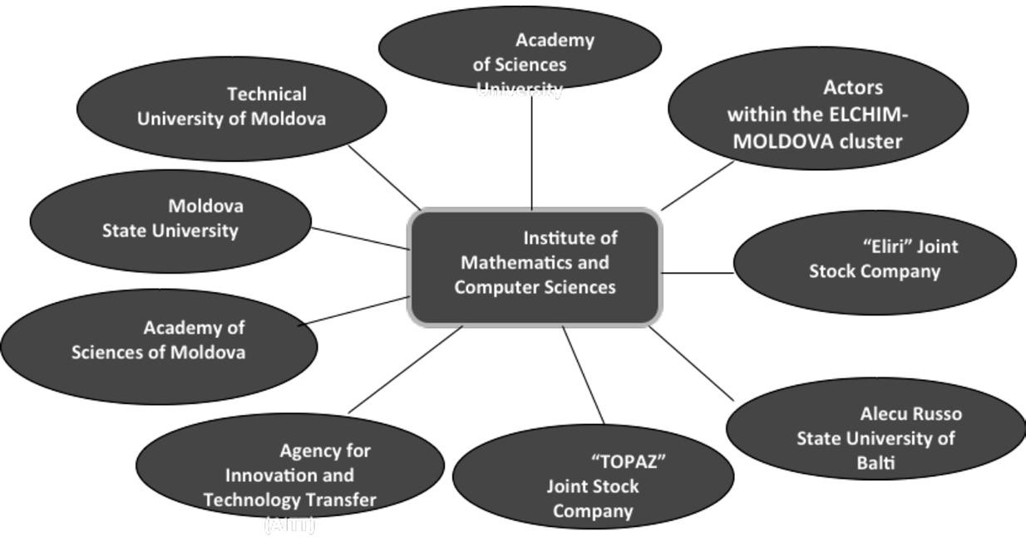

Figure 5: Actors within the Elchim-Moldova cluster

InnoCluster is another cluster in Moldova with a bottom-up approach. It is located in Comrat State University in the autonomous territorial unit of Gagauzia. It aims to develop the economy of Gagauzia through scientific and technical cooperation.

The main participants of InnoCluster are:

- The Executive Committee of Gagauzia

- Comrat State University

- Agrotehnica College

- The Diversified Vocational School in Comrat

- The Chamber of Commerce and Industry of Moldova in Gagauzia

- The Gagauzia Business Club.

The members of InnoCluster engage collectively in the following activities:

- Establish joint scientific research programmes

164

- Exchange scientific and technical literature, scientific and technical documents, etc.

- Forming an effective innovation system in Gagauzia

- Conducting joint seminars, conferences, forums, etc., in the field of innovation

- Attracting investments necessary for joint projects, etc.

3.6.7 RISKS OF CLUSTER DEVELOPMENT POLICY

As clusters are relatively new to the Moldovan economy, they may give rise to a number of risks and possible barriers in the course of their develop-ment. Some of the main risks are:

- Entrepreneurs are insufficiently experienced in associating and co-operating with one another. Most entrepreneurs do not recognize the potential of associating and cooperating with their peers because they traditionally resolve their problems independently. When enterpris-es come together in a cluster, they should establish common goals meeting the interests of each enterprise.

- Lack of open access to the business information environment. Entre-preneurs must communicate freely with one another when they are cooperating in a partnership. The cluster will only be effective if its business managers and cluster members are able to exchange infor-mation.

- The results of a cluster only manifest after a significant period of time. Since the impact of clusters is not immediate and they do not yield quick positive results immediately, managers of enterprises (and SMEs in particular) are unwilling to take the risk to develop clusters.

- Lack of legislative framework. Although some legislative policy docu-ments support the notion of clusters, the main issues related to the creation and development of clusters are not regulated.

- Low interest of companies and research institutions in cooperation. The low level of innovative connections between the scientific com-munity and businesses in Moldova is confirmed by international rank-ings. According to the Global Innovation Index 2014, Moldova had a score of 28.0 and ranked 123 out of 143 countries in cooperation between the business, scientific and educational communities. When these figures are compared to Moldova’s ranking in 2011-2013, it is evident that cooperation between businesses and scientific and edu-cational communities fell by 1.4 percentage points (see Table 5).

165

Table 5: Evolution of Moldovan cooperation between academia, the scientific community and industry in the Global Innovation Index
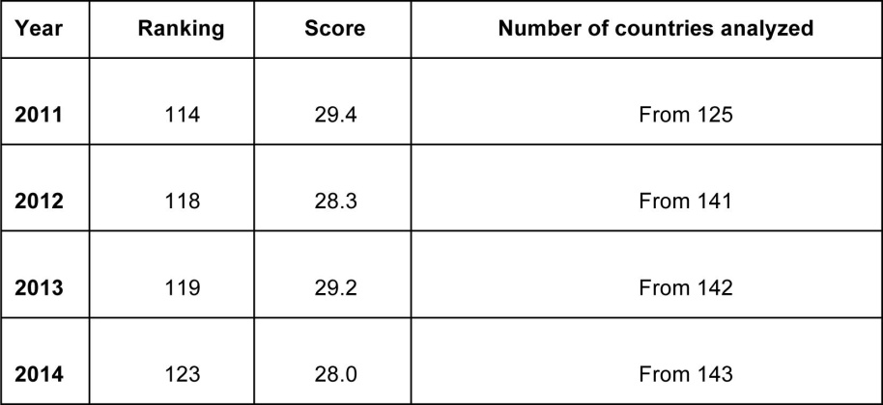

Source: Global Innovation Index Report, 2011-2014. Online at https:// www.globalinnovationindex.org/content.aspx?page=gii-full-report-2014 (accessed 12 August 2014).

3.6.8 CONCLUSIONS AND PROPOSALS

Despite the importance of the SME sector in the economy of the Republic of Moldova, many Moldovan enterprises have limited capacity hindering their competitive growth. By combining resources and jointly developing innovations through clusters, SMEs would be able to grow.

Cluster creation is still in the initial stage in Moldova, as the Moldovan Min-istry of Economy only adopted the Concept of Cluster Development of the Republic of Moldova’s Industrial Sector in 2013. This concept compiles the prerequisites for the development of clusters in the industrial sector, sets out the goals and objectives of the government’s cluster policy, outlines the stages of policy implementation, details the mechanisms of state sup-port for cluster development, and lists actions that should be taken.

Since clusters are still new in the Moldovan economy, a number of risks and possible barriers may arise in the cluster policy development process.

The barriers and risks to cluster formation and efficiency should be taken into account when the next stages of cluster-related policies are devel-oped.

166

The implementation of clusters and the development of cluster policies will help strengthen the cooperative capacity of SMEs.

Further steps in the development of cluster policies include:

- Developing policy documents on clusters creation and development to include the concept of clusters and mechanisms for cluster support in policy documents and laws. The lack of necessary legislation also limits the possibilities of cluster creation. Even though clusters are included and referenced in some policy documents, their creation and development are not regulated at the legislative level. Thus, introduc-tion of the concept of clusters in legislation, defining the regulatory mechanisms and outlining state support are necessary for clusters development.

- Educate businesses on the new opportunities related to cluster devel-opment. In order to popularize clusters and promote their benefits, enterprises and business associations should be educated on the pos-itive impact of clusters for cluster members, industries, the region and the national economy. Meetings, seminars, workshops, media publications and informative brochures should be utilized in stressing the importance of clusters and the benefits they yield. In addition to information dissemination, local government bodies should create close contacts with business associations by supporting and promot-ing cluster cooperation to interested enterprises so that they will be-come the core of the prospective cluster.

- Develop a map of clusters. Research institutes and business asso-ciations have to cooperate in the development of a cluster map in Moldova at the national and regional levels. This map should also pinpoint the relevant branches of the cluster. A pilot project for such a map should analyze the development prospects of each region, and indicate the sectors and regions that will benefit the most from clus-ters. The cluster map should also be updated periodically.

- Organize training for facilitators and managers of clusters. Persons from enterprises interested in clusters should be trained in the inter-action process at all stages of cooperation in order for cluster devel-opment to take off. People who should be trained are managers of large companies, entrepreneurs in the SME sector, specialists in vari-ous scientific and technological fields, local authorities and politicians, and representatives of branch associations and non-governmental organizations. Training will help raise awareness of the benefits of cluster creation, promote the advantages of partnership cooperation

167

and competitiveness, and highlight the positive impact of interacting with competitors.

- Further expand upon industrial cluster development, and institute a guide for cluster development. Now that the government has ap-proved the Concept of cluster development in the industrial sector of Moldova, the cluster development strategy should be expanded. This strategy should specify the provisions for cluster development and lay down the necessary directions before clusters are implemented. By doing this, clusters in Moldova will meet their objectives and achieve positive results. An action plan for the implementation of this strat-egy should determine the activities, responsibilities, timelines and resources needed for the successful achievement of cluster policy.

- Identify those enterprises that will form the cluster core and innova-tive component.

- To encourage the development of international clusters through the participation of SMEs from neighbouring countries. Moldova would be able to participate in joint projects with other EU countries in such an endeavour.

- Extending the mode of cooperation in clusters to other non-industrial enterprises so that they will form clusters and facilitate the develop-ment of SMEs. Sectors of the economy that will benefit from interfirm cooperation and clusters are tourism and agriculture.

REFERENCES

- E. Aculai, A. Bulgac, N. Vinogradova, A. Novac, and T. Colesnicova.

Fundamentarea mecanismului de susţinere a întreprinderilor mici şi mijlocii exportatoare de mărfuri şi servicii de producţie proprie. Ra-port ştiinţific (final). Chişinău: IEFS, 2009.

- E. Aculai, N. Vinogradova, A. Novac, A. Bulgac, V. Clipa, and L. Maier.

Identificarea problemelor principale ale ÎMM din Moldova şi elabo-rarea materialelor metodice pentru crearea şi dezvoltarea clusterelor. Raport ştiinţific. Chişinău: IEFS, 2010.

- E. Aculai, N. Vinogradova, A. Novac, N. Percinschi, V. Clipa, L. Ţurcan, and L. Maier. Analiza formelor existente de organizare a dialogului dintre ÎMM şi organele administraţiei publice, identificarea mecani-smelor de consolidare a acestui dialog la diferite nivele de adminis-trare. Chişinău: IEFS, 2011.

168

- E. Aculai, N. Vinogradova, N. Percinschi, A. Timus, A. Novac, L. Maier, and M. Doga-Mirzac. Analiza posibilităţilor şi constrângerilor în con-solidarea parteneriatului dintre IMM-uri, instituţiile publice şi mediul de cercetare în vederea creşterii competitivităţii afacerilor. Raport ştiinţific. Chişinău: INCE, 2014.

- Moldovan State Agency on Intellectual Property (AGEPI). Annual Re-port 2011-2013. Chişinău: AGEPI. Online at http://www.agepi.md/ ro/publication/50 (accessed 10 November 2015).

- Ministry of Economy of the Republic of Moldova. Strategia de dez-voltare a sectorului întreprinderilor mici şi mijlocii pentru anii 2012-2020, Publicată în Monitorul Oficial nr.198-204/740 dated 21 Septem-ber 2012. Chişinău: Moldovan Ministry of Economy, 2012. Online at http://www.mec.gov.md/sites/default/files/document/intr02_0.pdf

(accessed 10 November 2015).

- Ministry of Economy of the Republic of Moldova. Hotărîrea Guvernului nr.614 din 20 august 2013 cu privire la CONCEPŢIА dezvoltării cluste-riale a sectorului industrial al Republicii Moldova. Chişinău: Moldovan

Ministry of Economy, 2013. Online at http://www.mec.gov.md/sites/ default/files/document/intr02_0.pdf (accessed 10 November 2015).

- A. Novac, and L. Ghiţiu. Tendances dans le domaine de l’innovation et transfert de technologie dans les PME. Ediţia a IX a Conferenţei ştiinţifice internaţionale “Politici şi mecanisme de inovare şi dez-voltare a proceselor economico-financiare şi sociale în plan naţional şi internaţional,” (Chişinău: USM, 2014): 259-264.

- A. Novac, and N. Vinogradova. “Analiza premiselor pentru crearea clusterelor în Republica Moldova.” In Progrese în teoria deciziilor eco-nomice în condiţii de risc şi incertitudine, Vol. XXIII (Iaşi: Tehnopress,

2013): 133-138.

- Global Innovation Index Reports, 2011-2014. Online at https://www. globalinnovationindex.org/content/page/data-analysis/ (accessed 10 November 2015).

- World Intellectual Property Organization (WIPO). 2009. Recommen-dations for strengthening the role of small and medium-sized innova-tion enterprises in countries of the Commonwealth of Independent States. Geneva: WIPO. Online at http://www.wipo.int/export/sites/ www/dcea/en/pdf/tool_6.pdf (accessed 10 November 2015).

